1. Buatlah program menghitung nilai mahasiswa!

Jawab :

Source Code 1:

class Mahasiswa:

def __init__(self, nim, nama):

self.nim = nim

self.nama = nama

def validate_input(self, prompt, data_type):

while True:

try:

value = data_type(input(prompt))

return value

except ValueError:

print("Input salah. Masukkan Nilai dengan tipe data yang benar (Float) !")

def hitung_nilai(self):

nilai_tugas_1 = self.validate_input("Nilai Tugas 1: ", float)

nilai_tugas_2 = self.validate_input("Nilai Tugas 2: ", float)

nilai_tugas_3 = self.validate_input("Nilai Tugas 3: ", float)

nilai_uts_mid = self.validate_input("Nilai UTS (MID): ", float)

nilai_uas_final = self.validate_input("Nilai UAS (FINAL): ", float)

nilai_kehadiran = self.validate_input("Nilai Kehadiran (Absensi): ", float)

total_nilai_tugas = (nilai_tugas_1 + nilai_tugas_2 + nilai_tugas_3) / 3

total_nilai_akhir = (total_nilai_tugas * 20 / 100) +

(nilai_uts_mid *30 / 100) + (nilai_uas_final * 40 / 100) + (nilai_kehadiran * 10 / 100)

if total_nilai_akhir >= 85:

grade = "A"

elif total_nilai_akhir >= 80 and total_nilai_akhir <= 85:

grade = "A-"

elif total_nilai_akhir >= 75 and total_nilai_akhir <= 80:

grade = "B+"

elif total_nilai_akhir >= 70 and total_nilai_akhir <= 75:

grade = "B"

elif total_nilai_akhir >= 65 and total_nilai_akhir <= 70:

grade = "B-"

elif total_nilai_akhir >= 60 and total_nilai_akhir <= 65:

grade = "C+"

elif total_nilai_akhir >= 55 and total_nilai_akhir <= 60:

grade = "C"

elif total_nilai_akhir >= 40 and total_nilai_akhir <= 55:

grade = "D"

else:

grade = "E"

print("\nOutput Rangkuman Nilai Yang Didapat")

print("NIM:", self.nim)

print("Nama Mahasiswa:", self.nama)

print("Nilai Tugas:", total_nilai_tugas)

print("Nilai UTS (MID):", nilai_uts_mid)

print("Nilai UAS (FINAL):", nilai_uas_final)

print("Nilai Kehadiran (Absensi):", nilai_kehadiran)

print("Mendapatkan Nilai Akhir:", total_nilai_akhir)

print("Nilai Huruf (Grade):", grade)

print("Lulus:", total_nilai_akhir >= 60)

Source Code 2:

from mahasiswa import Mahasiswa

print("=====================================================")

print("======== Program menghitung nilai mahasiswa =========")

print("========== CREATED BY 222362 MOCH ACHMAR ============")

print("=====================================================")

mahasiswa = Mahasiswa(input("Masukkan NIM: "),

input("Masukkan Nama Mahasiswa: "))

while True:

mahasiswa.hitung_nilai()

ulang = input("Apakah ingin menginput ulang? (Y/T) atau (y/t): ")

if ulang.lower() != "y":

break

Hasil :

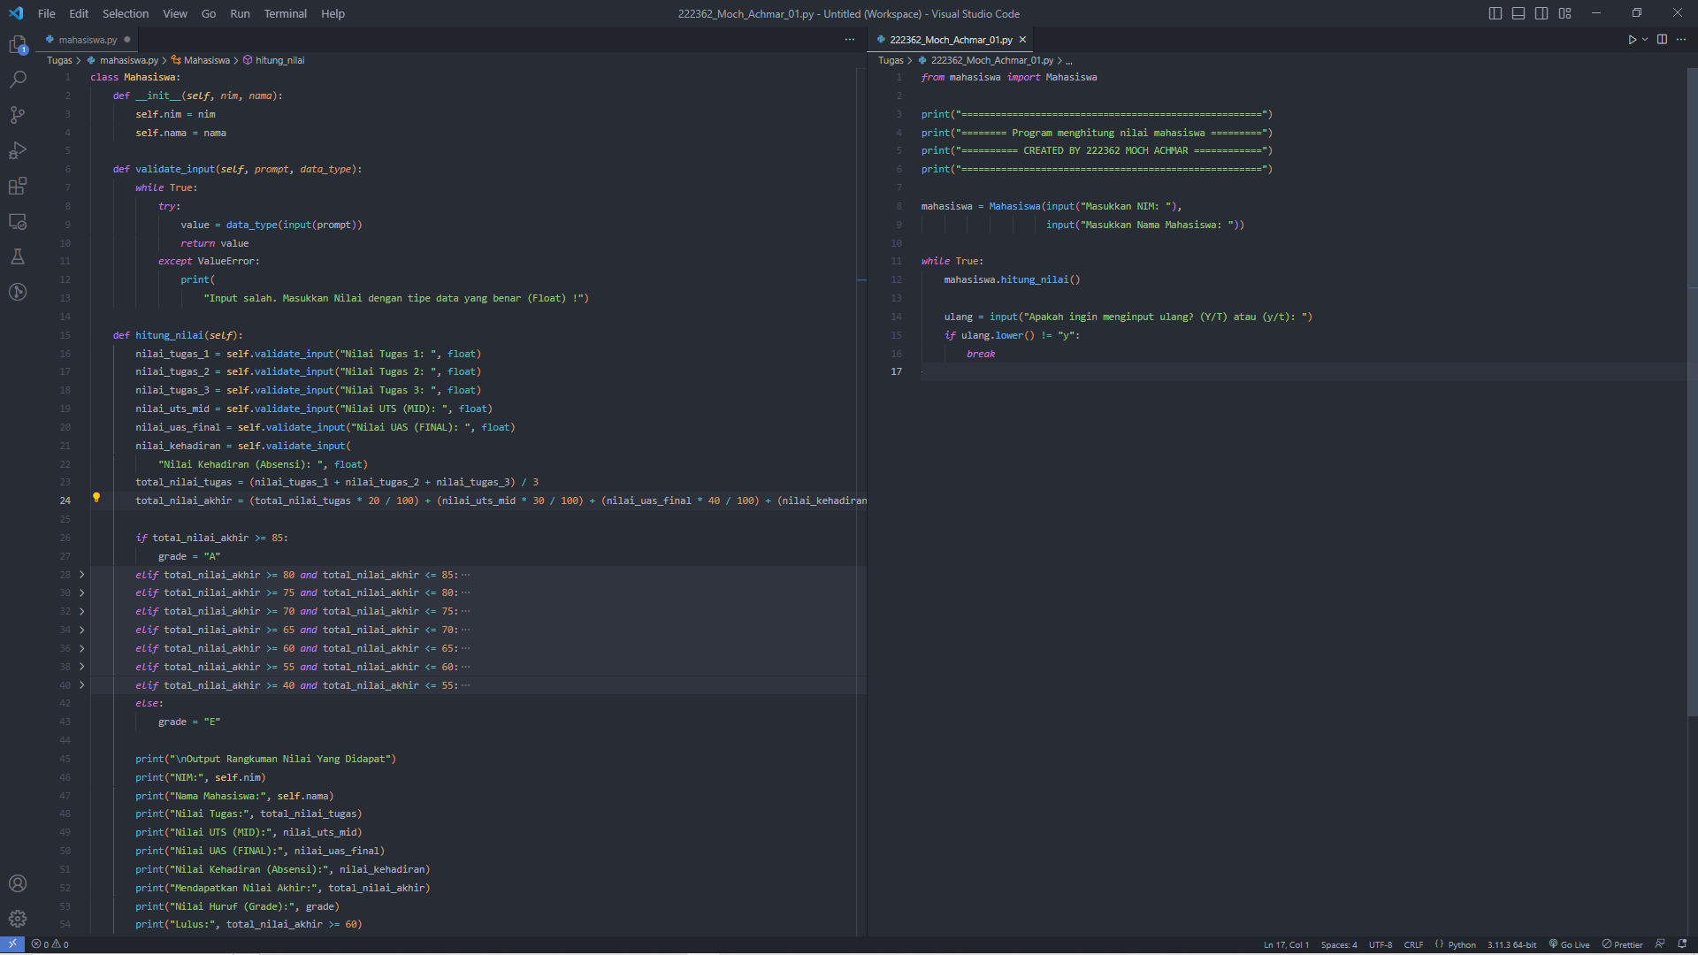

Hasil :

